YUVAINTERN – WEEK 4 INTERNSHIP REPORT

Predictive Modeling and Optimization of Delivery Time in Logistics Systems
Internship Role: Logistics Data Analyst Intern
Prepared by: Shamini S.
Program: B.Tech Artificial Intelligence & Data Science
Institution: Kumaraguru College of Technology
Internship: YuvaIntern
Month: September 2026

Executive Summary
This project develops a predictive modeling and optimization workflow for logistics delivery-time management. A simulated dataset containing 1,500 shipment records was created with operational variables including distance, weight, traffic level, weather condition, carrier, vehicle type, warehouse processing time, and shipment priority. The target variable was delivery time measured in days.
The project followed an end-to-end data science workflow consisting of data-quality validation, exploratory data analysis, data preprocessing, predictive model development, model evaluation, cross-validation, hyperparameter tuning, prediction-error analysis, feature interpretation, and operational scenario optimization.
Three regression models were evaluated: Linear Regression, Decision Tree Regressor, and Random Forest Regressor. Linear Regression produced the strongest test performance with a Mean Absolute Error (MAE) of 0.541 days, Root Mean Squared Error (RMSE) of 0.675 days, and R² of 0.885. Five-fold cross-validation produced a mean MAE of 0.553 days with a standard deviation of 0.025 days.
The optimization stage evaluated 27 combinations of carrier, vehicle type, and priority for a fixed shipment scenario. The baseline configuration predicted a delivery time of 6.94 days. The configuration with the lowest predicted delivery time among the tested combinations was Carrier A with a Heavy Truck and Urgent priority, with a predicted delivery time of 5.59 days. This represents a predicted reduction of 1.35 days, approximately 32.4 hours.
Because the dataset is simulated and does not contain transportation costs, vehicle capacity, route restrictions, or service-level constraints, the optimization result should be interpreted as a scenario-analysis result rather than a universal operational recommendation.

1. Introduction
Logistics organizations need to estimate delivery times accurately to support shipment planning, customer communication, resource allocation, and service-level management.
Delivery time can be affected by several operational conditions, including shipment distance, shipment weight, traffic congestion, weather conditions, carrier selection, vehicle type, warehouse processing time, and shipment priority.
Predictive analytics provides a method for estimating delivery time before or during shipment processing. Once a predictive model is available, different operational configurations can also be evaluated through scenario analysis.
This project combines predictive modeling with optimization-oriented scenario analysis. Python and machine learning techniques were used to develop a model for delivery-time prediction and evaluate alternative logistics configurations.
The project uses a simulated dataset to demonstrate the complete analytical workflow.

2. Project Objectives
The main objectives of this project are:
- To prepare and validate a logistics shipment dataset for predictive modeling.
- To identify relationships between operational factors and delivery time.
- To perform exploratory data analysis using numerical summaries and visualizations.
- To preprocess numerical and categorical variables appropriately.
- To train multiple regression models for delivery-time prediction.
- To compare models using MAE, RMSE, and R².
- To validate model stability using five-fold cross-validation.
- To perform hyperparameter tuning using GridSearchCV.
- To analyze prediction errors and model coefficients.
- To evaluate alternative operational configurations.
- To propose practical logistics optimization strategies.
- To document the complete implementation using Python.

3. Dataset Description
A simulated logistics dataset containing 1,500 shipment records was created using Python.
The dataset contains eight input variables and one target variable.
Feature | Type | Description
Distance_km | Numerical | Shipment distance in kilometres
Weight_kg | Numerical | Shipment weight
Traffic_Level | Categorical | Low, Medium, or High
Weather | Categorical | Clear, Cloudy, Rainy, or Stormy
Carrier | Categorical | Carrier A, Carrier B, or Carrier C
Vehicle_Type | Categorical | Van, Truck, or Heavy Truck
Warehouse_Processing_Hours | Numerical | Time spent processing the shipment at the warehouse
Priority | Categorical | Standard, Express, or Urgent
Delivery_Time_Days | Numerical Target | Delivery time in days
The target variable was generated using relationships between the operational variables and a random noise component.
A fixed random seed of 42 was used so that the simulated dataset and analysis could be reproduced.

4. Data Quality Analysis
The dataset contained:
- 1,500 rows
- 9 columns
- 0 missing values
- 0 duplicate records

4.1 Data Quality Summary
Data Quality Check | Result
Number of records | 1,500
Number of columns | 9
Missing values | 0
Duplicate rows | 0
The absence of missing values meant that no missing-value imputation was required.
No duplicate records were identified, so no duplicate-removal operation was necessary.

4.2 Numerical Summary
Variable | Mean | Minimum | Maximum
Distance_km | 1267.13 | 51 | 2499
Weight_kg | 500.22 | 1.19 | 999.71
Warehouse Processing Hours | 12.21 | 1.00 | 23.93
Delivery Time Days | 7.53 | 1.66 | 13.24
The average delivery time in the dataset was approximately 7.53 days.

5. Exploratory Data Analysis
Exploratory Data Analysis (EDA) was performed to identify relationships between logistics variables and delivery time.
The analysis focused on distance, traffic, weather, and carrier performance.

5.1 Distance and Delivery Time
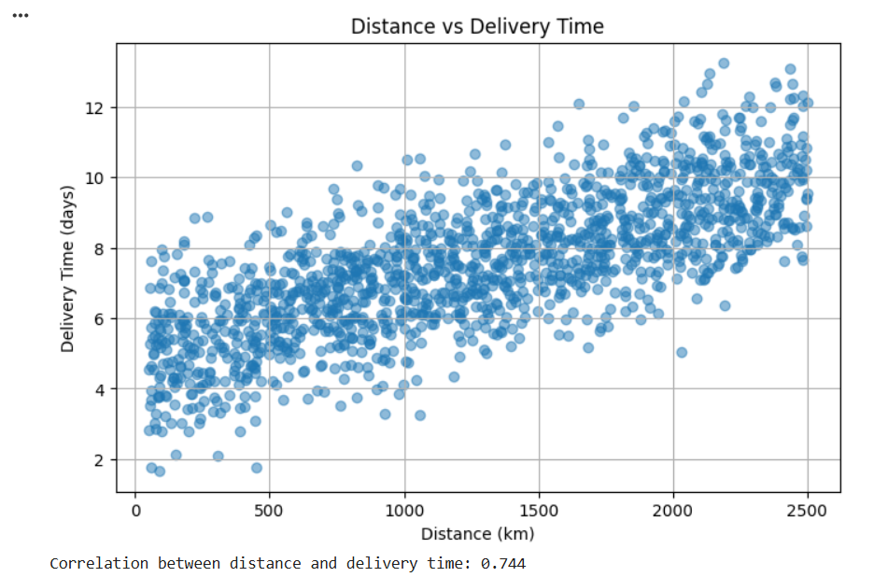

Chart 1 – Distance vs Delivery Time
The correlation between distance and delivery time was:
Correlation = 0.744
This indicates a strong positive relationship between shipment distance and delivery time in the simulated dataset.

Interpretation
As shipment distance increases, delivery time generally increases.

Business Implication
Distance should be considered when estimating expected delivery time. Longer routes may require larger delivery-time buffers and more detailed route planning.

5.2 Traffic Analysis
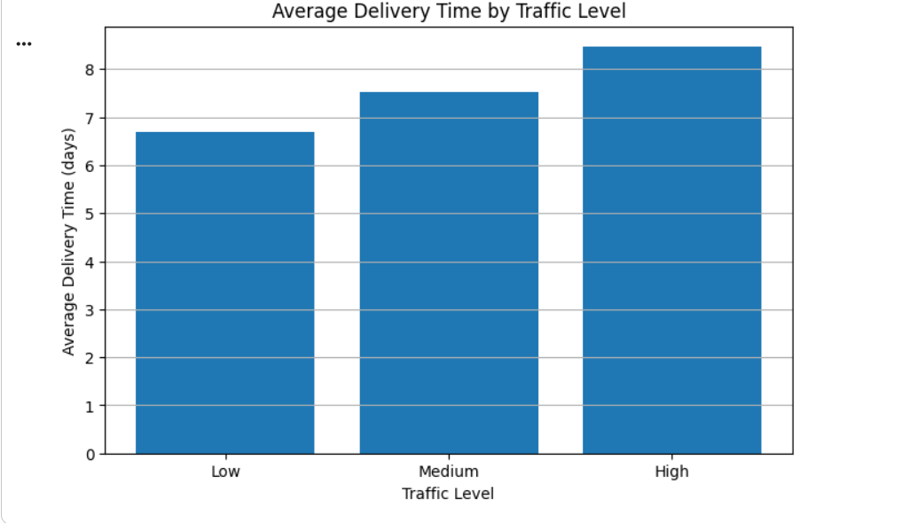

Chart 2 – Average Delivery Time by Traffic Level
The average delivery times were:
Traffic Level | Shipments | Average Delivery Time
Low | 429 | 6.70 days
Medium | 677 | 7.52 days
High | 394 | 8.47 days
The difference between Low and High traffic was:
8.47 − 6.70 = 1.77 days
This is approximately 42.5 hours.

Interpretation
High traffic conditions were associated with longer delivery times.

Business Implication
Traffic-aware route planning and dispatch timing can help reduce exposure to high-congestion conditions.

5.3 Weather Analysis
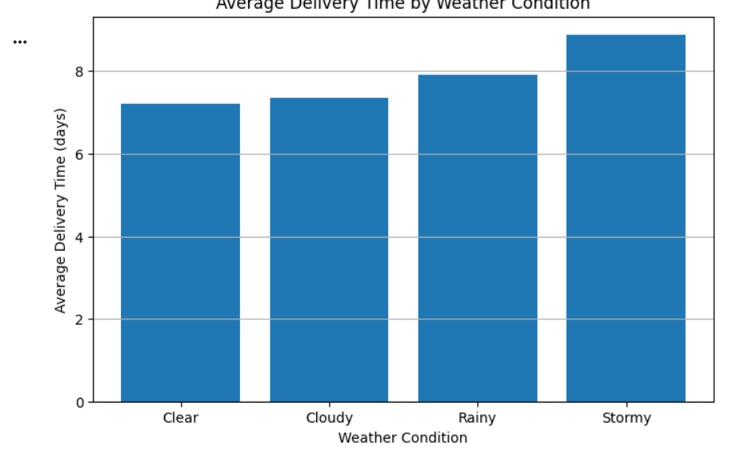

Chart 3 – Average Delivery Time by Weather Condition
Weather | Shipments | Average Delivery Time
Clear | 699 | 7.22 days
Cloudy | 368 | 7.35 days
Rainy | 307 | 7.91 days
Stormy | 126 | 8.88 days
The difference between Clear and Stormy weather was:
8.88 − 7.22 = 1.66 days
This is approximately 39.8 hours.

Interpretation
Delivery times increased as weather conditions became more severe.

Business Implication
During adverse weather conditions, logistics organizations can introduce additional delivery buffers and contingency planning.

5.4 Carrier Analysis
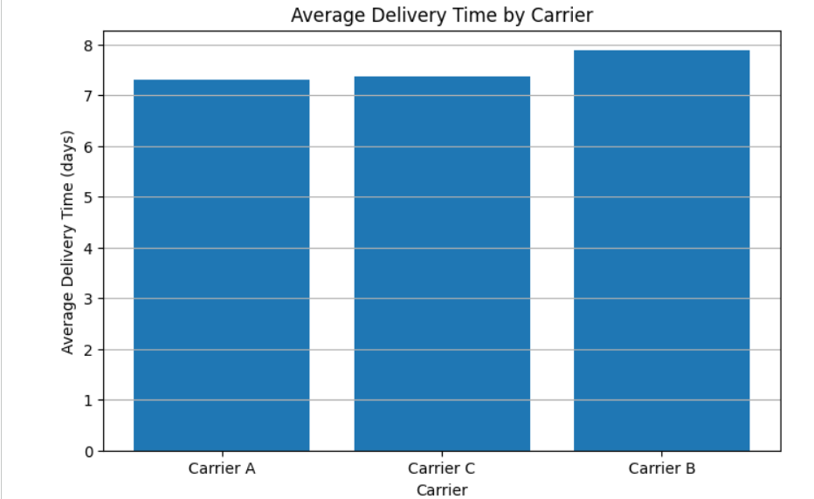

Chart 4 – Average Delivery Time by Carrier
Carrier | Shipments | Average Delivery Time
Carrier A | 488 | 7.31 days
Carrier C | 492 | 7.38 days
Carrier B | 520 | 7.89 days
The difference between the lowest and highest observed carrier averages was:
7.89 − 7.31 = 0.58 days

Interpretation
The observed carrier averages differed by approximately 0.58 days.

Business Implication
Carrier performance can be incorporated into delivery-time scenario analysis. However, carrier selection should not be based only on delivery time because real-world decisions also depend on cost, capacity, reliability, service-level agreements, and geographic coverage.

6. Data Preprocessing
The target variable was separated from the input features.
The input dataset contained:

Numerical Features
- Distance_km
- Weight_kg
- Warehouse_Processing_Hours

Categorical Features
- Traffic_Level
- Weather
- Carrier
- Vehicle_Type
- Priority
Categorical variables were converted into numerical representations using OneHotEncoder.
The dataset was divided into:
- Training set: 1,200 records
- Testing set: 300 records
This represents an 80:20 train-test split.

Python Implementation
X = data.drop("Delivery_Time_Days", axis=1)
y = data["Delivery_Time_Days"]

X_train, X_test, y_train, y_test = train_test_split(
X,
y,
test_size=0.20,
random_state=42
)

categorical_features = [
"Traffic_Level",
"Weather",
"Carrier",
"Vehicle_Type",
"Priority"
]

numerical_features = [
"Distance_km",
"Weight_kg",
"Warehouse_Processing_Hours"
]

preprocessor = ColumnTransformer(
transformers=[
(
"categorical",
OneHotEncoder(handle_unknown="ignore"),
categorical_features
)
],
remainder="passthrough"
)

7. Model Development
Three regression algorithms were evaluated.

7.1 Linear Regression
Linear Regression was selected as an interpretable baseline model.
linear_model = Pipeline(
steps=[
("preprocessor", preprocessor),
("model", LinearRegression())
]
)

linear_model.fit(X_train, y_train)

y_pred_linear = linear_model.predict(X_test)

7.2 Decision Tree Regressor
A Decision Tree Regressor was used to capture possible non-linear relationships.
tree_model = Pipeline(
steps=[
("preprocessor", preprocessor),
("model", DecisionTreeRegressor(
random_state=42,
max_depth=10
))
]
)

tree_model.fit(X_train, y_train)

y_pred_tree = tree_model.predict(X_test)

7.3 Random Forest Regressor
Random Forest was selected as an ensemble model capable of capturing more complex relationships.
random_forest_model = Pipeline(
steps=[
("preprocessor", preprocessor),
("model", RandomForestRegressor(
n_estimators=200,
random_state=42,
max_depth=12
))
]
)

random_forest_model.fit(X_train, y_train)

y_pred_rf = random_forest_model.predict(X_test)

8. Model Evaluation
The following evaluation metrics were used:

Mean Absolute Error (MAE)
MAE measures the average absolute difference between actual and predicted delivery time.

Root Mean Squared Error (RMSE)
RMSE gives greater importance to larger prediction errors.

R² Score
R² measures the proportion of variation in the target variable explained by the model.

8.1 Model Comparison
Model | MAE | RMSE | R²
Linear Regression | 0.541 | 0.675 | 0.885
Random Forest | 0.715 | 0.896 | 0.797
Decision Tree | 0.941 | 1.185 | 0.645

Linear Regression Interpretation
The Linear Regression model achieved:
- MAE = 0.541 days
- RMSE = 0.675 days
- R² = 0.885
The MAE of 0.541 days is approximately:
0.541 × 24 = 12.98 hours
Therefore, the average absolute prediction error was approximately 13 hours.
The R² value of 0.885 means that approximately 88.5% of the variation in the test delivery-time values was explained by the model.

9. Model Selection
Based on the test-set evaluation, Linear Regression produced the lowest MAE and RMSE and the highest R² among the three evaluated models.
Therefore, Linear Regression was selected as the final model for the optimization scenario analysis.
The selection was supported by:
- Test MAE of 0.541 days
- Test RMSE of 0.675 days
- Test R² of 0.885
- Five-fold CV MAE of 0.553 days
- CV standard deviation of 0.025 days
- High interpretability
The result should be interpreted within the context of the simulated dataset. Since the target variable was generated using predefined additive relationships, Linear Regression is naturally well suited to this dataset.

10. Five-Fold Cross-Validation
Five-fold cross-validation was used to evaluate model stability.
The training process was repeated across five validation folds.

Results
Model | Mean CV MAE | Standard Deviation
Linear Regression | 0.553 | 0.025
Random Forest | 0.715 | 0.027
Decision Tree | 0.999 | 0.018
Linear Regression achieved a mean cross-validation MAE of 0.553 days.
The standard deviation was 0.025 days, showing relatively stable performance across the folds.

Python Code
cv_scores = cross_val_score(
linear_model,
X,
y,
cv=5,
scoring="neg_mean_absolute_error"
)

cv_mae = -cv_scores

print("Mean CV MAE:", cv_mae.mean())
print("Std CV MAE:", cv_mae.std())

11. Hyperparameter Tuning
Random Forest hyperparameters were optimized using GridSearchCV.
The following parameters were tested:
- Number of estimators: 100 and 200
- Maximum depth: 8, 12, and None
- Minimum samples split: 2 and 5

Python Code
rf_pipeline = Pipeline(
steps=[
("preprocessor", preprocessor),
("model", RandomForestRegressor(
random_state=42
))
]
)

param_grid = {
"model__n_estimators": [100, 200],
"model__max_depth": [8, 12, None],
"model__min_samples_split": [2, 5]
}

grid_search = GridSearchCV(
estimator=rf_pipeline,
param_grid=param_grid,
cv=5,
scoring="neg_mean_absolute_error",
n_jobs=-1
)

grid_search.fit(X_train, y_train)

Best Parameters
Parameter | Selected Value
n_estimators | 200
max_depth | 12
min_samples_split | 2
Best GridSearch CV MAE | 0.738 days
The tuned Random Forest achieved:
- Test MAE = 0.715 days
- Test RMSE = 0.896 days
- Test R² = 0.797
Hyperparameter tuning did not improve the Random Forest's held-out test performance compared with the original Random Forest configuration.
The GridSearchCV score of 0.738 days was calculated during tuning on the training split, whereas the earlier 0.715-day cross-validation result was calculated using the full dataset. These are different validation setups and therefore should not be treated as identical estimates.

12. Prediction Error Analysis
Additional prediction-error analysis was performed for the selected Linear Regression model.
Error Measure | Result
Mean Absolute Error | 0.541 days
Maximum Absolute Error | 1.987 days
Predictions within 1 day | 87.00%
Predictions within 0.5 day | 55.00%
The maximum absolute error was approximately:
1.987 × 24 = 47.7 hours
Therefore, the largest observed prediction error was approximately 47.7 hours.

Interpretation
Approximately 87% of the predictions were within one day of the actual delivery time.
Approximately 55% were within half a day.
These measures provide a more practical interpretation of model accuracy than aggregate metrics alone.

13. Actual vs Predicted Delivery Time
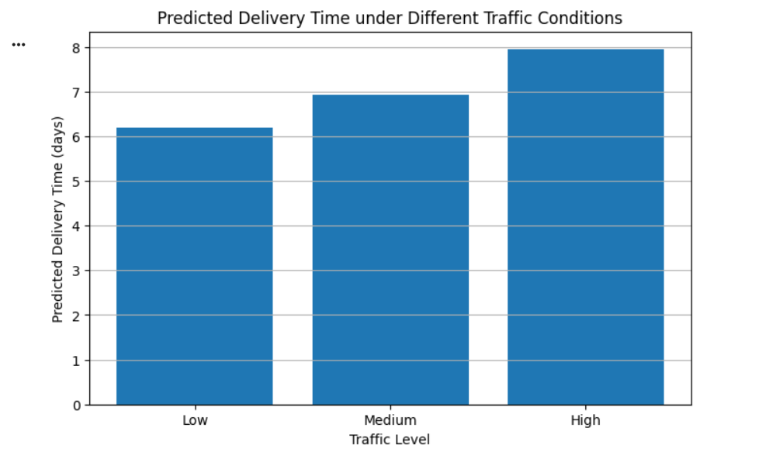

Chart 5 – Actual vs Predicted Delivery Time
The actual delivery times were compared with the delivery times predicted by the Linear Regression model.
The model showed a strong agreement between predicted and actual values, which is consistent with the R² value of 0.885.
The prediction analysis also showed that 87% of predictions were within one day of the actual delivery time.

Business Implication
A delivery-time prediction system can provide an estimated expected delivery time for planning, customer communication, and operational monitoring.

14. Linear Regression Feature Interpretation
The fitted Linear Regression coefficients were analyzed to understand which transformed features had larger positive or negative model coefficients.
Important coefficients included:
Feature | Coefficient
Weather_Stormy | +0.934
Traffic_Level_High | +0.924
Traffic_Level_Low | −0.836
Priority_Standard | +0.686
Weather_Clear | −0.634
Priority_Urgent | −0.564
Weather_Cloudy | −0.426
Carrier_B | +0.341
Carrier_A | −0.306
Vehicle_Type_Van | +0.271

Interpretation
The model assigned relatively large coefficients to traffic and weather categories. This is consistent with the EDA results, where high traffic and severe weather were associated with longer delivery times.
The coefficient analysis should not be interpreted as proof of causation.
Because OneHotEncoder was configured without dropping a category, all category levels were retained. Therefore, the coefficients should be interpreted as joint model coefficients rather than simple comparisons against one omitted reference category.

15. Optimization Scenario
The predictive model was extended from prediction to operational scenario analysis.
A fixed shipment scenario was defined.
Input | Value
Distance | 1,200 km
Weight | 500 kg
Warehouse Processing | 12 hours
Traffic | Medium
Weather | Clear
Carrier | Carrier A
Vehicle | Truck
Priority | Standard
The baseline predicted delivery time was:
6.94 days

16. Carrier Scenario Analysis
For the fixed shipment scenario:
Carrier | Predicted Delivery Time
Carrier A | 6.94 days
Carrier C | 7.21 days
Carrier B | 7.59 days
Compared with Carrier A:
- Carrier C was approximately 0.27 days slower.
- Carrier B was approximately 0.65 days slower.
The 0.65-day difference corresponds to approximately:
0.65 × 24 = 15.6 hours

17. Traffic Scenario Analysis
For the same shipment:
Traffic Level | Predicted Delivery Time
Low | 6.19 days
Medium | 6.94 days
High | 7.95 days
The difference between Low and High traffic was:
1.76 days
This is approximately:
42.2 hours
This demonstrates the potential operational value of traffic-aware planning.

18. Weather Scenario Analysis
For the same shipment:
Weather | Predicted Delivery Time
Clear | 6.94 days
Cloudy | 7.15 days
Rainy | 7.70 days
Stormy | 8.51 days
The difference between Clear and Stormy conditions was:
1.57 days
This corresponds to approximately:
37.7 hours
This supports the use of weather-aware buffers and contingency planning.

19. 27-Configuration Optimization
Three carriers, three vehicle types, and three priority levels were evaluated.
Therefore:
3 × 3 × 3 = 27 configurations
The following Python logic was used:
from itertools import product

optimization_data = []

carriers = [
"Carrier A",
"Carrier B",
"Carrier C"
]

vehicles = [
"Van",
"Truck",
"Heavy Truck"
]

priorities = [
"Standard",
"Express",
"Urgent"
]

for carrier, vehicle, priority in product(
carriers,
vehicles,
priorities
):

scenario = pd.DataFrame({
"Distance_km": [1200],
"Weight_kg": [500],
"Traffic_Level": ["Medium"],
"Weather": ["Clear"],
"Carrier": [carrier],
"Vehicle_Type": [vehicle],
"Warehouse_Processing_Hours": [12],
"Priority": [priority]
})

predicted_time = linear_model.predict(
scenario
)[0]

optimization_data.append({
"Carrier": carrier,
"Vehicle_Type": vehicle,
"Priority": priority,
"Predicted_Delivery_Time_Days":
predicted_time
})

optimization_results = pd.DataFrame(
optimization_data
)

optimization_results = optimization_results.sort_values(
"Predicted_Delivery_Time_Days"
).reset_index(drop=True)

20. Optimization Results
The configuration with the lowest predicted delivery time among the 27 tested configurations was:
Parameter | Configuration
Carrier | Carrier A
Vehicle Type | Heavy Truck
Priority | Urgent
Predicted Delivery Time | 5.59 days
The baseline configuration was:
Parameter | Configuration
Carrier | Carrier A
Vehicle Type | Truck
Priority | Standard
Predicted Delivery Time | 6.94 days
Therefore:
Predicted reduction = 6.94 − 5.59 = 1.35 days
In hours:
1.35 × 24 = 32.4 hours

21. Optimization Visualization

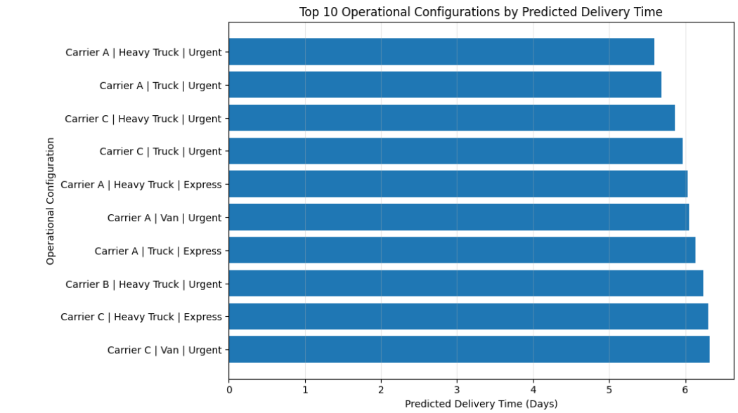

Chart 6 – Top 10 Operational Configurations
The chart compares the ten configurations with the lowest predicted delivery times among the 27 tested combinations.
The lowest predicted delivery time was:
5.59 days
Configuration:
Carrier A + Heavy Truck + Urgent
The baseline configuration produced:
6.94 days
The difference was:
1.35 days or approximately 32.4 hours

Business Interpretation
The scenario analysis demonstrates how a predictive model can be extended beyond forecasting to compare possible operational configurations.
However, the lowest predicted delivery-time configuration should not automatically be treated as the operationally optimal choice.
A real logistics organization would also need to consider:
- Transportation cost
- Vehicle availability
- Vehicle capacity
- Fuel consumption
- Driver availability
- Route restrictions
- Customer requirements
- Service-level agreements
- Priority-related service costs

22. Optimization Recommendations
Based on the predictive modeling and scenario analysis, the following strategies can be considered.

22.1 Predictive Dispatch Planning
Use predicted delivery times as an additional input during dispatch planning.
Instead of relying only on historical average delivery time, planners can estimate expected delivery time for individual shipment conditions.

22.2 Traffic-Aware Route Planning
High traffic was associated with longer predicted delivery times.
Therefore, route planning and dispatch timing can be adjusted to reduce exposure to high-congestion periods where practical.

22.3 Weather-Based Delivery Buffers
Stormy weather produced higher delivery-time values than clear weather.
Additional buffers or contingency plans can therefore be considered during severe weather conditions.

22.4 Carrier Scenario Evaluation
Carrier performance can be evaluated using predicted delivery time together with other operational factors.
Carrier selection should consider:
- Delivery time
- Cost
- Capacity
- Reliability
- Service-level agreements

22.5 Vehicle Selection
Different vehicle types produced different predicted delivery times.
Vehicle selection should therefore consider both predicted delivery time and real-world vehicle capacity, operating cost, and availability.

22.6 Priority Management
Urgent priority produced lower predicted delivery time in the simulated scenario.
However, urgent service may have higher operational or financial costs in a real environment. Therefore, priority decisions should be based on customer requirements and service policies rather than prediction time alone.

23. Limitations
This project has several limitations.

23.1 Simulated Dataset
The dataset used in this project is simulated rather than collected from an actual logistics company.
Therefore, the model accuracy represents proof-of-concept performance and should not be interpreted as real-world delivery prediction accuracy.

23.2 Limited Operational Variables
Real logistics delivery time may also depend on:
- Route restrictions
- Fuel costs
- Vehicle capacity
- Driver availability
- Warehouse congestion
- Origin and destination
- Holidays
- Service-level agreements
- Real-time traffic
- Real-time weather
These variables were not included in the current dataset.

23.3 Cost Optimization
The optimization stage focused on minimizing predicted delivery time.
A complete cost optimization could not be performed because the dataset does not contain:
- Carrier cost
- Fuel cost
- Vehicle operating cost
- Route cost
- Penalty cost

23.4 Target Construction
The target variable was generated using predefined relationships between input variables.
This makes Linear Regression particularly suitable for the simulated dataset.
Real historical logistics data may contain more complex non-linear relationships.

23.5 Real-World Deployment
Before operational deployment, the model should be retrained and independently evaluated using historical shipment data.
Additional constraints and leakage checks should also be incorporated.

24. Overall Findings
The main findings from the project are summarized below.
Finding | Result
Dataset size | 1,500 shipments
Missing values | 0
Duplicate rows | 0
Distance correlation with delivery time | 0.744
Low traffic average | 6.70 days
High traffic average | 8.47 days
Clear weather average | 7.22 days
Stormy weather average | 8.88 days
Linear Regression MAE | 0.541 days
Linear Regression RMSE | 0.675 days
Linear Regression R² | 0.885
Linear Regression 5-fold CV MAE | 0.553 days
Predictions within 1 day | 87%
Configurations evaluated | 27
Baseline prediction | 6.94 days
Lowest tested prediction | 5.59 days
Predicted reduction | 1.35 days
Predicted reduction in hours | 32.4 hours

25. Conclusion
This project developed an end-to-end predictive modeling and optimization workflow for logistics delivery-time management.
A simulated dataset containing 1,500 shipment records was analyzed using data-quality validation, exploratory data analysis, preprocessing, machine learning, cross-validation, hyperparameter tuning, prediction-error analysis, feature interpretation, and optimization scenario analysis.
Three regression models were evaluated: Linear Regression, Decision Tree Regressor, and Random Forest Regressor.
Linear Regression produced the strongest test performance with:
- MAE = 0.541 days
- RMSE = 0.675 days
- R² = 0.885
Five-fold cross-validation produced a mean MAE of 0.553 days with a standard deviation of 0.025 days.
The analysis also identified measurable relationships between logistics conditions and delivery time. Distance had a correlation of 0.744 with delivery time. Average delivery time increased from 6.70 days under Low traffic to 8.47 days under High traffic. Similarly, average delivery time increased from 7.22 days under Clear weather to 8.88 days under Stormy weather.
The optimization stage evaluated 27 combinations of carrier, vehicle type, and priority for a fixed shipment scenario.
The baseline configuration produced a predicted delivery time of 6.94 days. The configuration with the lowest predicted delivery time among the tested combinations was Carrier A + Heavy Truck + Urgent, with a predicted delivery time of 5.59 days.
This represents a predicted reduction of:
1.35 days = approximately 32.4 hours
The project demonstrates how predictive modeling can support logistics planning by estimating delivery times and comparing operational scenarios.
For real-world deployment, the approach should be extended using historical shipment data and additional variables such as transportation cost, vehicle capacity, route constraints, fuel consumption, service-level agreements, and real-time traffic and weather conditions.

26. Python Implementation Documentation
The complete Python implementation followed these stages:
- Dataset generation
- Data-quality validation
- Exploratory Data Analysis
- Feature preparation
- Train-test splitting
- Categorical encoding
- Linear Regression
- Decision Tree Regression
- Random Forest Regression
- Model evaluation
- Five-fold cross-validation
- Random Forest hyperparameter tuning
- Prediction-error analysis
- Feature coefficient analysis
- Optimization scenario generation
- 27-configuration evaluation
- Optimization visualization
- Business interpretation
The Python implementation was performed in Google Colab.
The notebook contains the complete executable implementation, while representative code snippets are included in this report.

27. Key Python Evaluation Code
from sklearn.metrics import (
mean_absolute_error,
mean_squared_error,
r2_score
)

y_pred = linear_model.predict(X_test)

mae = mean_absolute_error(
y_test,
y_pred
)

rmse = np.sqrt(
mean_squared_error(
y_test,
y_pred
)
)

r2 = r2_score(
y_test,
y_pred
)

print(f"MAE: {mae:.3f}")
print(f"RMSE: {rmse:.3f}")
print(f"R2: {r2:.3f}")
Expected results:
MAE: 0.541
RMSE: 0.675
R2: 0.885

28. Optimization Code
best_option = optimization_results.iloc[0]

print("Optimal Operational Configuration")
print("---------------------------------")

print(
f"Carrier: "
f"{best_option['Carrier']}"
)

print(
f"Vehicle Type: "
f"{best_option['Vehicle_Type']}"
)

print(
f"Priority: "
f"{best_option['Priority']}"
)

print(
f"Predicted Delivery Time: "
f"{best_option['Predicted_Delivery_Time_Days']:.2f} days"
)

baseline_prediction = optimization_results[
(optimization_results["Carrier"] == "Carrier A") &
(optimization_results["Vehicle_Type"] == "Truck") &
(optimization_results["Priority"] == "Standard")
]["Predicted_Delivery_Time_Days"].iloc[0]

optimized_prediction = (
best_option["Predicted_Delivery_Time_Days"]
)

improvement = (
baseline_prediction -
optimized_prediction
)

print(
f"Baseline Configuration Prediction: "
f"{baseline_prediction:.2f} days"
)

print(
f"Optimized Configuration Prediction: "
f"{optimized_prediction:.2f} days"
)

print(
f"Predicted Reduction: "
f"{improvement:.2f} days"
)

print(
f"Predicted Reduction in Hours: "
f"{improvement * 24:.1f} hours"
)
Output:
Optimal Operational Configuration
---------------------------------
Carrier: Carrier A
Vehicle Type: Heavy Truck
Priority: Urgent
Predicted Delivery Time: 5.59 days

Baseline Configuration Prediction: 6.94 days
Optimized Configuration Prediction: 5.59 days
Predicted Reduction: 1.35 days
Predicted Reduction in Hours: 32.4 hours

29. GitHub Repository
GitHub Repository:
https://github.com/Shamini-tech/Yuva-Interns-Task-4/tree/main

Repository name:
Yuva Intern Task 4
The repository should contain:
- Google Colab notebook (.ipynb)
- README file
- Python implementation
- Project documentation
- Relevant supporting files
The GitHub repository provides a reproducible reference for the technical implementation used in this project.

30. Final Project Summary
The project successfully demonstrated the use of predictive analytics for logistics delivery-time forecasting and scenario-based optimization.
The final workflow connected:
Data → Cleaning → EDA → Preprocessing → Machine Learning → Evaluation → Cross-Validation → Hyperparameter Tuning → Prediction Analysis → Optimization → Business Recommendations
The project provides a foundation that can be extended to real logistics data and more advanced optimization objectives such as cost minimization, resource allocation, route optimization, and multi-objective logistics planning.

